

Accelerated National
Innovation Adoption
(ANIA)

Post IDA Brief

September 2025

Background to ANIA 2
Innovations Being Assessed at Strategic Case 4
Innovations Being Assessed at Value Case 5
Innovations in Delivery 7

Background to ANIA
The ANIA pathway, led by the Centre for Sustainable Delivery, in partnership with NHS National Services Scotland, Healthcare Improvement Scotland, Public Health Scotland, and NHS Education for Scotland, has been established to:
- identify innovations that should be considered for national adoption within the NHS
- produce robust value cases to assess their clinical and financial impact
- lead the national adoption of approved technologies at pace

The ANIA pathway is governed by the Innovation Design Authority (IDA), which brings together senior Scottish Government and NHS leadership. The IDA enables improved partnership working, system leadership and collective decision making relating to which technologies should progress through the ANIA stage gates (further detail on these stage gates is provided on the next page and on the ANIA website).
Decisions / key updates from 18 August 2025 IDA meeting
- ECG Patch Monitors Value Case approved subject to funding
- Chronic Liver Disease Early Detection Tests (ELF test and iLFT) to progress through the ANIA pathway to Strategic Case
- Home-testing devices for diagnosing obstructive Sleep Apnoea Hypopnoea Syndrome (OSAHS) is to progress through the ANIA pathway to Strategic Case
- HeartFlow FFRCT is to progress through the ANIA pathway, with work to start on the Strategic Case once the two above have been completed

Substantive items requiring decision at the 28 October 2025 IDA meeting
- TBC

Current Technologies within the ANIA Pathway
The technologies that are currently being assessed for adoption via the ANIA Stage Gates, or are being deployed nationally following approval, are outlined over the following pages.

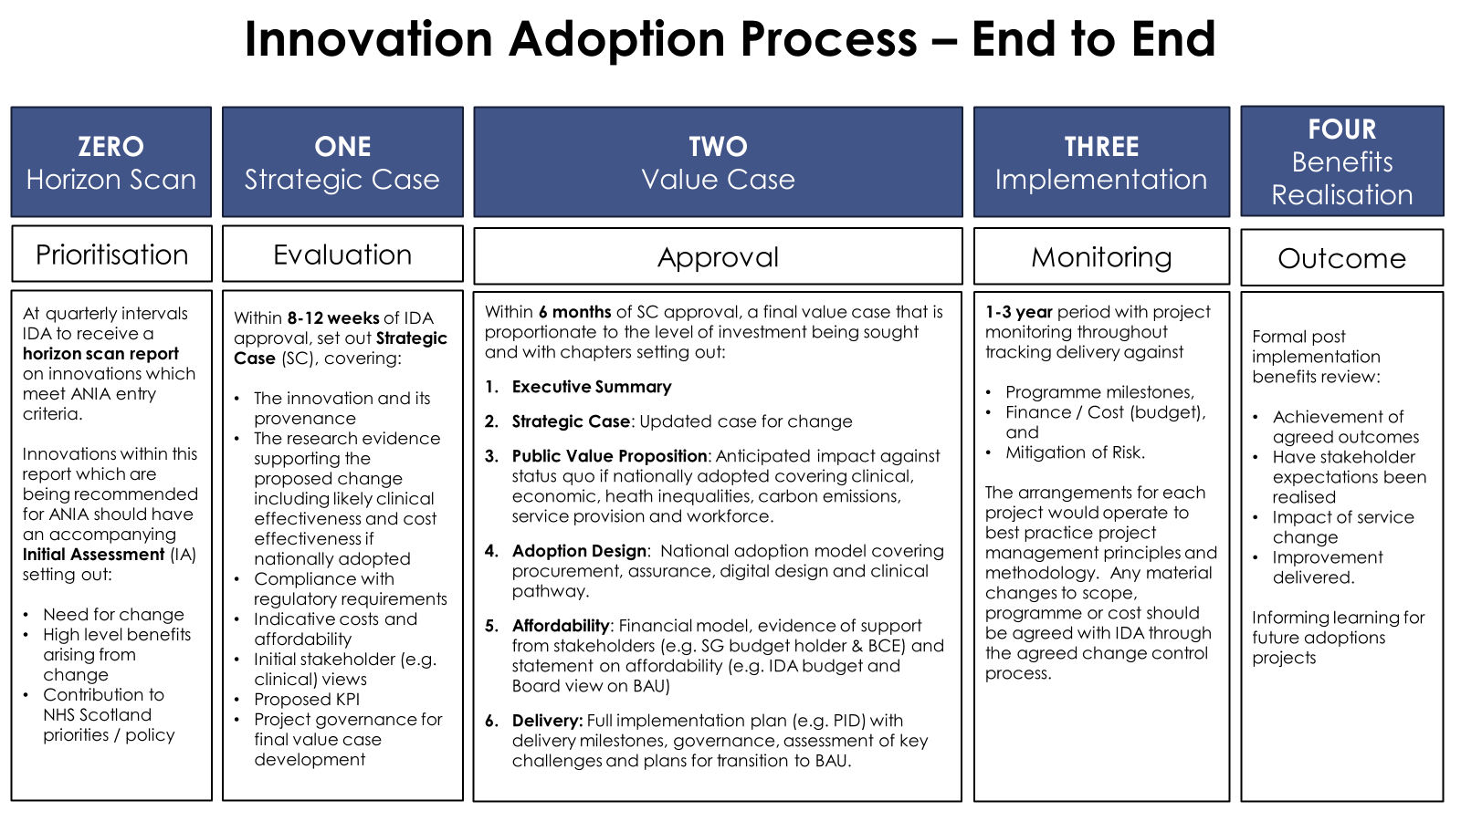

Innovations Being Assessed at Strategic Case
Strategic cases provide an early view of evidence, clinical acceptance and cost effectiveness for technologies that have been identified through the Horizon Scan process and approved by the IDA. They are completed within 12 weeks.

Chronic Liver Disease Tests
This Strategic Case will explore how the introduction of two blood tests can reshape the chronic liver disease (CLD) pathway by delivering earlier and more accurate diagnosis. The combined use of the Intelligent Liver Function Test (iLFT) and the Enhanced Liver Fibrosis (ELF) test can help reduce pressure on clinical waiting lists by accelerating decisions about which patients with suspected liver disease require referral to specialist liver clinics and which can be safely managed by their GP.
The Strategic Case will be presented to the IDA in December 2025.
OSAHS Home Testing Devices
This Strategic Case will explore how home testing devices for diagnosing Obstructive Sleep Apnoea Hypopnoea Syndrome (OSAHS) have the potential to enhance sleep services across Scotland - improving quality of life and easing pressure on NHS resources. Poor sleep is associated with worsened mental health (including anxiety, stress, and depression), physical health issues (heart disease, high blood pressure, obesity, and type 2 diabetes), and reduced cognitive function, which can have serious safety implications.

The Strategic Case will be presented to the IDA in December 2025.
HeartFlow FFRCT

This Strategic Case will explore HeartFlow, a cutting-edge diagnostic tool that can help to transform cardiovascular care. The technology converts a standard CT scan into a detailed 3D model of the coronary arteries, allowing clinicians to diagnose life-threating coronary heart disease in just twenty minutes. The alternative is that many patients must go in hospital for an invasive and time-consuming angiogram. Using HeartFlow means that people could be seen, diagnosed, and treated more quickly, resulting in better care for patients and reduced pressure on the service.
Work on this Strategic Case will commence later in 2025.
Innovations Being Assessed at Value Case
Value cases, developed over a six-month period, are an adapted treasury five case business model and include a detailed implementation plan. The approval process was recently reviewed and agreed by the IDA as follows:

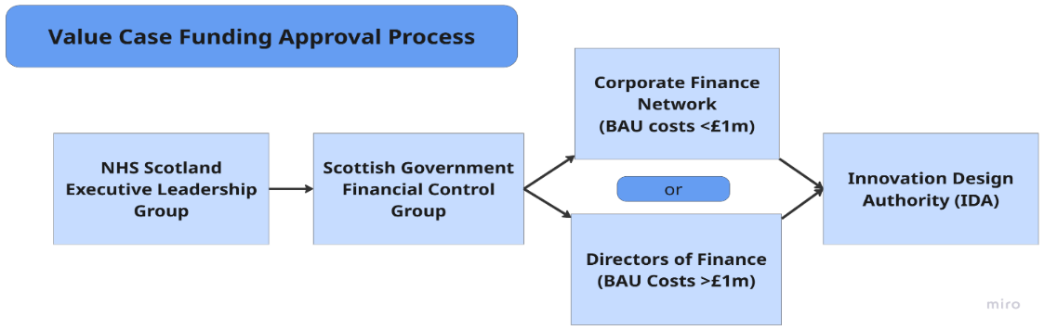

Digital Type 2 Diabetes Prevention
This Value Case proposes:
National deployment of a Digital Type 2 Diabetes Prevention Programme for 15,000 people living with pre-diabetes in Scotland over 3 years, which is predicted to prevent almost 4,000 people progressing to type 2 diabetes over 5 years post intervention, delivering almost £20 million of net savings for NHS Scotland.
This Value Case was approved at the June IDA, subject to funding.


Ambulatory ECG Patch Monitors
This Value Case Proposes:
- A new national clinical pathway for the adoption of adhesive single lead ECG devices (patches) for post cryptogenic stroke and transient ischemic attack patients that provide continuous monitoring for up to 14 days
- The opportunity to develop a national remote diagnostic service for Atrial Fibrillation which is predicted to prevent 689 recurrent strokes and deliver £14.6 million resource savings for NHS Scotland over five years. Adoption of the technology is also anticipated to save 1.3 million patient miles and release staff capacity equivalent to 15.7 WTE cardiac physiologists over this period.

The Value Case was approved at the August IDA, subject to funding.
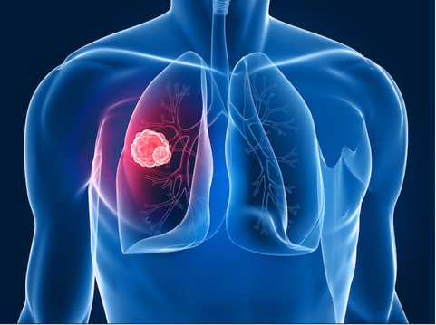
Lung Cancer AI
This Value Case proposes:
Accelerating the diagnosis of lung cancer following a GP requested chest x-ray by the national deployment of a ‘24/72’ diagnostic pathway enhancement where X-rays identified by the AI technology as ‘high risk’ will be reported within 24 hours and diagnostic CTs will take place within the subsequent 72 hours.
A unique opportunity to be the first UK nation to implement a national AI-enabled Lung Cancer diagnostic pathway enhancement.
The Value Case is currently scheduled for submission to the IDA during financial year 2025/26.

Innovations in Delivery
Technologies which have been approved for national implementation by both Scottish Government and NHS Scotland Health Boards.

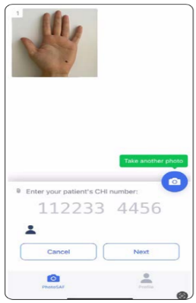
Digital Dermatology
National deployment of an image capture pass through app enabling Primary Care clinicians to use their own phone cameras to easily, and safely, take images of a patient’s skin condition at the point of referral to Dermatology. The use of triage-quality images as standard practice will provide all Dermatologists with the ability to carry out robust referral triage which can significantly speed up diagnosis and improve waiting times, enhancing patient journeys and outcomes.
Delivery Milestones - Key Highlights
- All 14 territorial Health Boards now have access to the Digital Dermatology image capture app.
- The first benefits realisation report was presented to the Programme Delivery Board (PDB) in July and the Innovation Design Authority (IDA) in August.
- Paper drafted outlining the key activities and requirements for transition to Business as Usual
Currently 100% of GP practices in Scotland are now able to capture and attach images to their Dermatology referrals.
As of 30th August, 7680 SCI Gateway referrals have been made with images attached using the Consultant Connect app.
Pharmacogenetics
This delivery programme includes two genetic tests:
- A lab-based test (CYP2C19 Genotype Testing) to identify ischemic stroke and TIA patients who are resistant to Clopidogrel
- A Point of Care Test (POCT) for neonates to prevent the permanent hearing loss caused by gentamicin-induced ototoxicity.
Following approval by the Innovation Design Authority and the NHS Executive Leadership Group, the Scottish Government announced funding (£1.9m) for the programme in March 2025.
Delivery Milestones – Key Highlights
- 6-month pre-implementation phase continues, with early adopting Health Boards due to go live in October 2025.
- Recruitment for Programme Implementation Team, including Clinical Leads, is near completion, with colleagues being on-boarded to start imminently.
- Recruitment within the two Genetic Labs is underway

- Health Board Readiness Questionnaires completed and early adopting Health Boards identified
- National DPIA template developed and reviewed by information governance leads
- Education packs developed and being prepared for distribution to Health Boards
- Communications plan developed and creation of toolkit is underway for each project
- Benefits realisation strategy is being developed
- Call-off contract to be signed by early adopting Health Board for Neonatal Gentamicin POCT.
Further information regarding the recent Scottish Government Ministerial visit can be found here: https://www.nhsggc.scot/genetic-test-to-prevent-hearing-loss-in-newborns-to-begin-national-rollout-in-nhs-greater-glasgow-and-clyde/
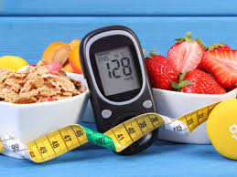

Digital Diabetes Remission
A national digital intensive weight management programme to support 3,000 people recently diagnosed with type 2 diabetes (T2DM). The national programme will run over three years and is expected to help around 40% of patients achieve remission from T2DM by the end of their first year on the programme.
The Scottish Government announced funding (£4.5m) for the programme in March 2025.
Delivery Milestones - Key Highlights
- Recruitment to clinical leadership and programme team roles near completion with preferred candidates progressing through pre-employment and onboarding processes
- Service specification finalised ahead of the procurement of the national digital programme provider.
- Invitation to tender published for the digital programme provider on 21st July with a tender submission date of 19th August. Submitted bids are now under analysis by the evaluation panel with an anticipated final contract award date of 6th October. Communications key messages created with communications toolkit under development. Focused engagement with Health Boards and GP practices also being planned.
- Benefits realisation strategy development in progress.
New market-ready technologies can also be referred to: Scotland Innovates

