

Venous leg ulcers are common and are associated with significant morbidity to the patient and cost to the NHS. Recent evidence has shown that early endovenous intervention on patients with active ulceration improves healing rates and reduces recurrence.

The National Venous Leg Ulcer Treatment Pathway should ensure timely and standardised treatment for patients with ulcers, with access to community venous leg ulcer clinics and early, streamlined referral into a vascular one-stop clinic where patients can be assessed and venous intervention planned and delivered in an appropriate timeframe.



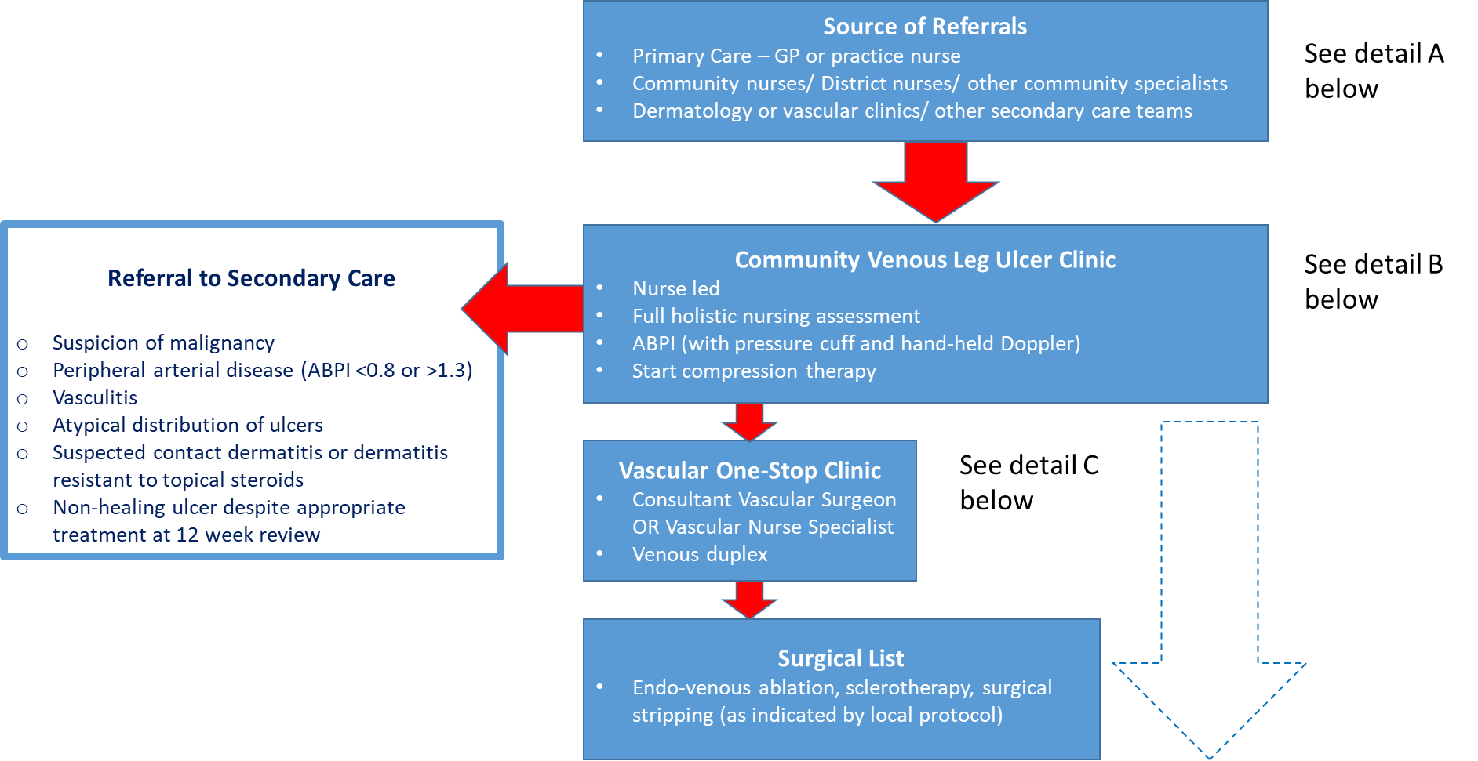

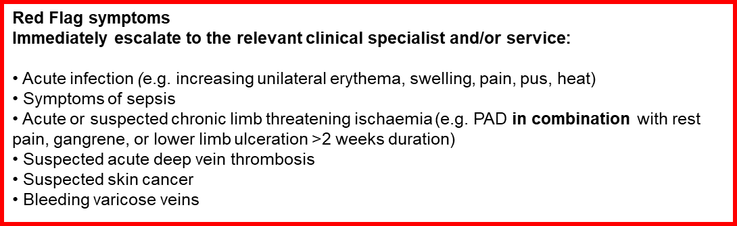

**Detail A: Patient referral to Community Venous Leg Ulcer Clinic**

* Source of referrals – Primary Care (GP or practice nurse), Community Service (District Nurse, podiatry, etc.), secondary care teams
* Triage presents an opportunity for streaming patients into the appropriate service. Patients with Red Flag symptoms should be referred urgently onto the relevant clinical specialist or service and should not be referred to the Community Venous Leg Ulcer Clinic

|  |  |
| --- | --- |
| **Inclusions** | **Exclusions** |
| Venous leg ulcers present for >4 weeks in non-housebound patients  A chronic venous leg ulcer can be defined as:  An open lesion between the knee and ankle joint that remains unhealed for at least 4 weeks and occurs in the presence of venous disease. Typically in the gaiter area of the lower leg (around the malleoli) | Suspicion of malignancy  Peripheral arterial disease  Vasculitis  Atypical distribution of ulcers  Suspected contact dermatitis, or dermatitis resistant to topical steroids  Housebound patients (should be referred to district nurses for assessment and treatment)  Non-healing ulcer despite appropriate treatment (>12 week) |

**Detail B: Community Venous Leg Ulcer Clinic (VLUC): Outline description**

* Staffed by appropriately trained, qualified nurses (not necessarily nurse specialist)
* Situated in community setting – clinic room including a low level sink (or equivalent). Ideally with bariatric / split leg bed
* New patient assessment clinic (allow for 90 – 120 minute slots):
  + Ankle Brachial Pressure Index (ABPI) with pressure cuff and hand-held Doppler
  + Glycated haemoglobin test – HbA1c (abnormal results will be fed back to GP)
  + Initiate compression bandaging
* Photography to confirm healing and to support referral if needed
* Return patient (bandaging) clinic (30 mins per leg)
  + Patient attends twice per week – reducing to once per week
  + Assessment is carried out at each dressing change and amendment to the treatment plan as necessary. Full re-assessment including ABPI (if little or no progress) carried out at 12 weeks, consider escalation to specialist services if no improvement
* Emphasis on following protocol for assessment and review bandaging. (Sample standard operating procedures are proved in the appendix below. These will need review / adaptation locally to ensure agreement with local arrangements). Use of an agreed wound formulary to ensure best practice and minimise unnecessary costs
* In some circumstances it may not be possible to get ABPIs measured immediately. Rather than delay instituting compression therapy in patients who are at low risk of pressure damage over bony prominences, consider offering first line reduced, graduated compression (20mmHg or less at the ankle) while waiting for ABPI measurement. Such patients will require close monitoring for skin integrity and signs of vascular insufficiency and should have ABPIs measured as soon as possible.
* Those with red flag symptoms should be escalated urgently to the relevant clinical specialty, but should also be considered for first line reduced graduated compression (20mmHg at the ankle). Such compression therapy is likely to be beneficial to most EXCEPT those with acute or suspected chronic limb threatening ischaemia where this should be avoided (1).
* Close working with Vascular Surgery and Dermatology for advice as needed. Photography and remote consultation (e.g. Near Me or Digital Dermatology) should support this.
* Discharge planning should start 2 to 3 weeks in advance of anticipated discharge. Relevant compression hosiery, applicators and creams should be ordered. Patients and carers should receive guidance (including written information) on self-care, including instruction on how to obtain repeat prescriptions from Primary Care, warning signs to look for and a contact number. For some patients (where supported by local protocol), wraps may be an appropriate alternative to hosiery.
* The service will usually offer a 6 week open appointment system that can be accessed via the contact number.

**Detail C: Onward referral from VLUC to Vascular Surgery Service for venous intervention**

Patients with ABPI between 0.8 and 1.3, where the patient is ambulant and physically able to attend for venous duplex, should be referred to a one stop clinic:

* Vascular lab (or equivalent) for venous duplex + review by Vascular Surgeon or Vascular Nurse Specialist for assessment and potential listing for:

a) endo-venous ablation

b) sclerotherapy

c) surgical stripping as per local protocol

* Input from Vascular Nurse Specialist where available
* Compression therapy (managed by VLUC) continues through surgical phase of pathway unless otherwise indicated



This pathways was produced in line with SIGN 120 guidance, which was subsequently withdrawn and replaced by NICE guidance. Consideration has also been given to ESCHAR trial (2) and EVRA trial(3) and further resources are also available at National Leg Ulcer (Scotland) Forum and the National Wound Care Strategy Programme.

1. National Wound Care Strategy Programme: Lower Limb Wounds – Leg Ulcer Recommendations July 2024

2. Long term results of compression therapy alone versus compression plus surgery in chronic venous ulceration (ESCHAR): randomised controlled trial. Gohel et al, BMJ 2007, 335, 83.

3. A Randomized Trial of Early Endovenous Ablation in Venous Ulceration. Gohel et al, NEJM 2018, 378, 22, 2105-14.

**APPENDIX 1**

The following appendices are intended as outlines for Health Boards to develop their own Standard Operating Procedures. The examples below have been adapted from those used by the clinical team at NHS Tayside. These may need to be adjusted or expanded depending on availability of facilities (e.g. photography) and services locally and to ensure links are established with relevant local services (e.g. Primary Care, District Nursing, Vascular Surgery, Dermatology).

**APPENDIX I Venous Leg Ulcer Clinic Standard Operating Procedure (SOP) for Assessment of Venous Leg Ulcers**

**1.0 Purpose/Background**

Lack of appropriate clinical assessment of patients with limb ulceration in the community has often led to long periods of ineffective treatment (RCN, 2024). Therefore it is advisable that the cause of ulceration should be diagnosed through holistic assessment of the patient, including a full clinical history and physical assessment including assessment of the leg and of the ulcer itself. The aim of this SOP is to ensure safe and standardised assessment of venous leg ulcers.

**2.0 Scope**

This SOP applies all registered nurses working within the Community Venous Leg Ulcer Clinic.

**3.0 Responsibility**

All registered nurses are responsible for reading this SOP and signing to say they have understood this SOP and will comply with the instructions within.

**4.0 Procedure**

4.1 Introduce all staff to the patient.

4.2 Confirm the patients name and date of birth.

4.3 Explain to the patient what they can expect from the consultation.

4.4 Commence full holistic assessment, including review of comorbidities and social circumstances affecting prognosis

4.5 The leg should then be assessed for signs of venous disease*, oedema and joint mobility, particularly that of the ankle, as this is an important component of the calf muscle pump function.

**\* Signs of Venous Disease**

* Usually shallow ulcers situated on the gaiter area of the leg
* Oedema
* Eczema
* Ankle flare
* Lipodermatosclerosis
* Varicose veins
* Hyperpigmentation/haemosiderin staining
* Atrophie blanche

4.6 The leg should also be assessed for signs of arterial disease* **and any other Red Flag symptoms**. Sufficient arterial supply is required to safely apply compression therapy, which is the standard treatment for venous leg ulcers. Measurement of the ankle brachial pressure index (ABPI) by hand held Doppler device is the most reliable way to detect arterial insufficiency (see SOP Measurement of ABPI).

**Red Flag symptoms**

**Immediately escalate to the relevant clinical specialist and/or service:**

* Acute infection (e.g., increasing unilateral erythema, swelling, pain, pus, heat)
* Symptoms of sepsis
* Acute or suspected chronic limb threatening ischaemia (e.g., PAD **in combination** with rest pain, gangrene, or lower limb ulceration >2 weeks duration)
* Suspected acute deep vein thrombosis
* Suspected skin cancer
* Bleeding varicose veins

**\*Signs of Arterial Disease**

* Ulcers with a ’punched out’ appearance
* Base of wound poorly perfused and pale
* Cold legs/feet (in a warm environment)
* Shiny, taut skin
* Dependent rubour
* Pale or blue feet
* Gangrenous toes

Mixed Venous/Arterial

These will have features of a venous ulcer, in combination with signs of arterial impairment.

* 1. The ulcer itself should then be assessed. Deep ulcers which involve deep fascia, tendon, periosteum or bone may have an arterial component to their aetiology and should be referred for specialist assessment (see criteria for referral to secondary care below).
  2. The ulcer should be measured; serial measurement of the surface area is a reliable index of healing. This should be done through tracing the wound and measuring the two maximum perpendicular axes.
  3. An accurate clinical description of the wound should be documented (in the leg ulcer assessment record if this is used). This should include a description of the wound edge e.g. shallow, epithelialising, punched out, a description of the base of the ulcer e.g. granulating, sloughy and the position of the ulcer on the leg should be clearly described.
  4. Compression therapy may be safely used in the absence of any signs of arterial disease and following the measurement of ABPI (where ABPI is between 0.8 and 1.3 inclusive) (see SOP Treatment of Venous Leg Ulcers).
  5. Where there may be a delay in obtaining ABPI measurement, consider implementing first line reduced, graduated compression (20mmHg or less at the ankle). Those with symptoms that should be escalated to secondary care should be referred on urgently but also considered for first line mild graduated compression (20mmHg at the ankle).

Such compression therapy is likely to be beneficial to most **EXCEPT** those with acute or suspected chronic limb threatening ischaemia.

* 1. Assessment should be carried out at each dressing change and a full Reassessment including Doppler should be carried out at 12 weeks. If there is no progress/improvement the patient should be referred to the specialist leg ulcer clinic (see criteria for referral to secondary care below).
  2. If the leg shows signs of infection please refer to the local protocols for management of suspected infection in chronic wounds and ulcers.

**5.0 Criteria for referral to secondary care**

* Suspicion of malignancy
* Peripheral arterial disease (ABPI <0.8 or >1.3)
* Vasculitis
* Atypical distribution of ulcers - Suspected contact dermatitis or dermatitis resistant to topical steroids
* Non-healing ulcer despite appropriate treatment at 12 week review

**6.0 Related Documents**

Venous Leg Ulcers – NICE Guidance (revised October 2024):

RCN Clinical Practice Guideline - The nursing management of patients with venous leg ulcer recommendations <https://cks.nice.org.uk/topics/leg-ulcer-venous/>

**APPENDIX 2: Venous Leg Ulcer Clinic Standard Operating Procedure for Assessment of Ankle Brachial Pressure Index (ABPI)**

**1.0 Purpose/Background**

Lack of appropriate clinical assessment of patients with limb ulceration in the community has often led to long periods of ineffective treatment (RCN, 2024). The role of Doppler ultrasound in detecting arterial insufficiency is considered an essential part of the assessment process for chronic leg ulcer management (NICE 2024). It should be used in conjunction with the medical history, physical assessment and clinical presentation of the ulcer. The aim of this SOP is to ensure safe and standardised care of venous leg ulcers in the Community Venous Leg Ulcer Clinic.

**2.0 Scope**

This SOP applies to all registered nurses working within the Community Venous Leg Ulcer Clinic.

**3.0 Responsibility**

All trained nurses are responsible for reading this SOP and signing to say they have understood this SOP and will comply with the instructions within.

**4.0 Procedure**

It is the individual staff member’s responsibility to ensure they work within their level of competence. This procedure should only be carried out by staff who are trained and competent to do so.

4.1 Introduce all staff to the patient. Confirm the patients name and date of birth.

Explain to the patient what they can expect from the assessment. Do not perform Doppler ultrasound if suspicion of DVT as it will be painful and may dislodge the clot.

4.2 Rest patient for at least 15 minutes before commencing the procedure. Patient should lie flat. However, if patient has problems with this due to breathing or arthritis, lie the patient as flat as is comfortably tolerated and document this in the patients record.

4.3 Place the blood pressure cuff around the patient’s arm (the cuff should be the correct size for the limb)

|  |  |  |  |
| --- | --- | --- | --- |
| Indication | Width (cm) | Length (cm) | Limb Circ (cm) |
| Small Adult/Child | 10-12 | 18-24 | <23 |
| Standard Adult | 12-13 | 23-35 | <33 |
| Large Adult | 12-16 | 35-40 | <50 |
| Adult Thigh Cuff | 20 | 42 | <53 |

British Hypertension Society (2006)

4.4 Locate the brachial artery and apply a pea sized amount of ultrasound gel over it.

4.5 Switch on Doppler. Hold probe at 45-60 degree angle to the blood vessel and direct it into the blood flow. If no sound is heard, try adjusting the angle of the probe. Do not press the probe down into the patient as this is uncomfortable and can compress the vessel.

4.6 Inflate the cuff while holding the probe over the pulse until any sound disappears. Slowly deflate the cuff and when the sound reappears this indicates systolic pressure. Document this figure.

4.7 Repeat the procedure for the other arm.

4.8 Cover ulcer with cling film and apply the blood pressure cuff just above the malleoli to cover the gaiter area.

4.9 Locate one foot pulse (the posterior tibial, peroneal, anterior tibial or dorsal pedial pulse can be used)

4.10 Apply ultrasound gel and position the probe at a 45-60 degree angle in the direction of the blood flow as previously described.

4.11 Inflate the cuff while holding the probe over the pulse until any sound disappears. Slowly deflate the cuff and when the sound reappears this indicates systolic pressure. Document this figure.

4.12 Locate a second foot pulse and repeat the procedure.

4.13 Repeat for the other limb.

4.14 To calculate the left ABPI: Divide the highest of the two ankle readings for the left leg by the higher of the two brachial pressures.

4.15 To calculate the right ABPI: Divide the highest of the two ankle readings for the right leg by the higher of the two brachial pressures.

4.16 Interpret the ABPI 1 within the context of a full medical history, physical assessment and clinical presentation of the ulcer.

4.17 Patients should have another Doppler assessment at 12 weeks if there are signs of delayed healing or poor healing. Then as indicated at 3-monthly intervals until the ulcer is healed. If there is no progress/improvement, the patient should be referred to the specialist leg ulcer clinic (see criteria for referral to secondary care below).

**5.0 Criteria for referral to secondary care** - Suspicion of malignancy

* Peripheral arterial disease (ABPI <0.8 or >1.3)
* Vasculitis
* Atypical distribution of ulcers
* Suspected contact dermatitis or dermatitis resistant to topical steroids
* Non-healing ulcer despite appropriate treatment at 12 week review

**6.0 Related Documents**

Venous Leg Ulcers – NICE Guidance (revised October 2024): <https://cks.nice.org.uk/topics/leg-ulcer-venous/>

RCN Clinical Practice Guideline – The nursing management of patients with venous leg ulcers Recommendations (October 2024)

**APPENDIX 3: Community Venous Leg Ulcer Clinic Standard Operating Procedure (SOP) for Treatment of Venous Leg Ulcers**

**1.0 Purpose/Background**

Lack of appropriate clinical assessment of patients with limb ulceration in the community has often led to long periods of ineffective treatment (RCN, 2024). The mainstay treatment of a venous leg ulcer involves compression therapy to reduce venous hypertension. The aim of this SOP is to ensure safe and standardised care of venous leg ulcers in the Community Venous Leg Ulcer Clinic.

**2.0 Scope**

This SOP applies to all registered nurses who are working within the Community Venous Leg Ulcer Clinic.

**3.0 Responsibility**

All registered nurses are responsible for reading this SOP and signing to say they have understood this SOP and will comply with the instructions within.

**4.0 Procedure**

4.1 Full assessment of the patient, the leg and the ulcer including ABPI measurement should be carried out prior to any treatment. This is to establish the aetiology of the ulcer and ensure effective treatment. (See SOP *Assessment of venous leg ulcers*)

* Patients with a reading of 0.8 to 1.3 (inclusive) with a clinical picture of venous ulceration, can safely have compression therapy applied
* < 0.8 indicates arterial disease should be referred to the specialist leg ulcer clinic (see criteria for specialist referral)
* < 0.5 contraindicates compression and requires an urgent vascular referral
* Results > 1.3 may be found in some patients with diabetes or advanced renal disease who have heavily calcified vessels. These patients should be referred to the specialist leg ulcer clinic (see criteria for referral to secondary care below.)
  1. Ulcerated legs should be washed in tap water. The leg should be immersed if possible in a floor sink or lined bucket/basin of warmed emollient solution (tap water with emulsifying ointment or diprobase cream) and dressings gently soaked off. This method cleanses the wound and moisturises the surrounding skin. The leg should then be carefully dried and an emollient applied.
  2. Topical corticosteroids may be required in the treatment of eczema or dermatitis (subject to local prescribing arrangements).
  3. The ulcer margins should be coated with a barrier preparation to prevent maceration of the surrounding skin (e.g. zinc paste)
  4. A simple non-adherent dressing should be used to cover the ulcerated areas. Alternative dressings should be selected using the relevant section of the local wound management formulary to meet the needs of the wound.
  5. High compression multi-component bandaging should be used to treat venous leg ulcers. Patients should be offered the strongest compression that maintains patient concordance. Practitioners should take into account patient preference, lifestyle, likely concordance and the required frequency of application. **Compression should only be applied by staff with appropriate training and in accordance with manufacturer’s instructions.**
  6. The Leg Ulcer Management form should be completed detailing the individual treatment plan.
  7. Patients should be contacted within 24 hours by phone or seen if assessed as necessary to identify any complications following initial application of compression therapy.
  8. Assessment should be carried out at each dressing change and amendments to treatment plan made as necessary. Full re-assessment including ABPI assessment should be carried out at 12 weeks. If there is no progress/improvement the patient should be referred to the specialist leg ulcer clinic (See criteria for specialist referral).

**5.0 Criteria for referral to secondary care -** Suspicion of malignancy

* Peripheral arterial disease (ABPI <0.8 or >1.3)
* Vasculitis
* Atypical distribution of ulcers
* Suspected contact dermatitis or dermatitis resistant to topical steroids o
* Non-healing ulcer despite appropriate treatment at 12 week review

**6.0 Related Documents**

Venous Leg Ulcers – NICE Guidance (revised October 2024): <https://cks.nice.org.uk/topics/leg-ulcer-venous/>

RCN Clinical Practice Guideline – The nursing management of patients with venous leg ulcers Recommendations (October 2024)