

Accelerated National
Innovation Adoption
(ANIA)

Post IDA Brief

July 2025

Background to ANIA…………………………………………………….2
Innovations Being Assessed at Value Case 4
Innovations in Delivery 5

Background to ANIA
The ANIA pathway, led by the Centre for Sustainable Delivery, in partnership with NHS National Services Scotland, Healthcare Improvement Scotland, Public Health Scotland, and NHS Education for Scotland, has been established to:
- identify innovations that should be considered for national adoption within the NHS
- produce robust value cases to assess their clinical and financial impact
- lead the national adoption of approved technologies at pace

The ANIA pathway is governed by the Innovation Design Authority (IDA), which brings together senior Scottish Government and NHS leadership. The IDA enables improved partnership working, system leadership and collective decision making relating to which technologies should progress through the ANIA stage gates (further detail on these stage gates is provided on the next page and on the ANIA website).
Decisions / key updates from 24 June 2025 IDA meeting
- Digital Type 2 Diabetes Prevention Value Case approved subject to funding

Substantive items requiring decision at the 18 August 2025 IDA meeting
- ECG Patch Monitors Value Case
- Horizon Scanning short-listed technologies moving to Strategic Case

Current Technologies within the ANIA Pathway
The technologies that are currently being assessed for adoption via the ANIA Stage Gates, or are being deployed nationally following approval, are outlined over the following pages.

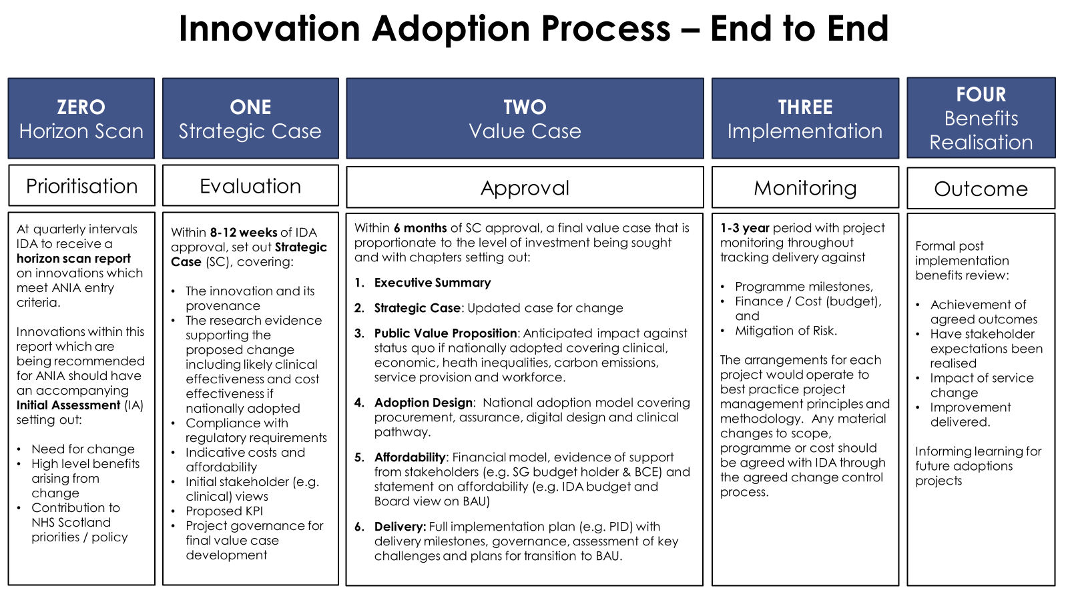

Innovations Being Assessed at Value Case
Value cases, developed over a six month period, are an adapted treasury five case business model and include a detailed implementation plan.


Digital Type 2 Diabetes Prevention
This Value Case proposes:
National deployment of a Digital Type 2 Diabetes Prevention Programme for 15,000 people living with pre-diabetes in Scotland over 3 years, which is predicted to prevent almost 4,000 people progressing to type 2 diabetes over 5 years post intervention, delivering almost £20 million of net savings for NHS Scotland
This Value Case was approved at the June IDA, subject to funding.

Ambulatory ECG Patch Monitors
This Value Case Proposes:
- A new national clinical pathway for the adoption of adhesive single lead ECG devices (patches) for post cryptogenic stroke and transient ischemic attack patients that provide continuous monitoring for up to 14 days
- The opportunity to develop a national remote diagnostic service for Atrial Fibrillation which is predicted to prevent 689 recurrent strokes and deliver £14.6 million resource savings for NHS Scotland over five years. Adoption of the technology is also anticipated to save 1.3 million patient miles and release staff capacity equivalent to 15.7 WTE cardiac physiologists over this period. With appropriate training, releasing cardiac physiology capacity has significant potential to enable the reallocation of existing labour resources towards other time-critical cardiovascular waiting lists, such as echocardiography for heart failure.
The Value Case will be submitted to the IDA in August 2025.
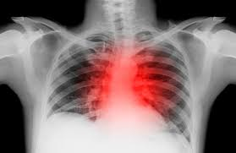
Lung Cancer AI
This Value Case proposes:
Accelerating the diagnosis of lung cancer following a GP requested chest x-ray by the national deployment of a ‘24/48’ diagnostic pathway enhancement where X-rays identified by the AI technology as ‘high risk’ will be reported within 24 hours and diagnostic CTs will take place within the subsequent 48 hours.
A unique opportunity to be the first UK nation to implement a national AI-enabled Lung Cancer diagnostic pathway enhancement.
The Value Case is currently scheduled for submission to the IDA during financial year 2025/26.

Innovations in Delivery
Technologies which have been approved for national implementation by both Scottish Government and NHS Scotland Health Boards.

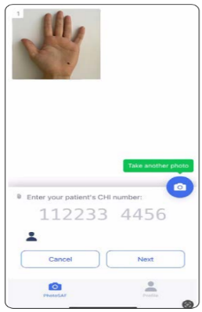
Digital Dermatology
National deployment of an image capture pass through app enabling Primary Care clinicians to use their own phone cameras to easily, and safely, take images of a patient’s skin condition at the point of referral to Dermatology. The use of triage-quality images as standard practice will provide all Dermatologists with the ability to carry out robust referral triage which can significantly speed up diagnosis and improve waiting times, enhancing patient journeys and outcomes.
Delivery Milestones - Key Highlights
- All 14 territorial Health Boards now have access to the Digital Dermatology image capture app.
- Some Boards have opted for a phased approach to rollout across GP practices and the Programme Team will continue to support Boards to roll out to remaining GP Practices.
- As Phase 2 of the programme progresses, Health Boards have been developing their optimisation plan for both primary and secondary care
- Data for the first benefits realisation report is being collated from across the Health Boards and will be presented to the Programme Delivery Board (PDB) in July and the Innovation Design Authority (IDA) in August.
Currently 70% of GP practices in Scotland are now able to capture and attach images to their Dermatology referrals.
As of 28th June, 4715 SCI Gateway referrals have been made with images attached using the Consultant Connect app.

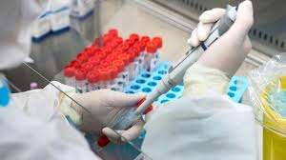
Pharmacogenetics
This delivery programme includes two genetic tests:
- A lab-based test (CYP2C19 Genotype Testing) to identify stroke and TIA patients who are resistant to Clopidogrel
- A Point of Care Test (POCT) for neonates to prevent the permanent hearing loss caused by gentamicin-induced ototoxicity.
Following approval by the Innovation Design Authority and the NHS Executive Leadership Group, the Scottish Government announced funding (£1.9m) for the programme in March 2025.
Delivery Milestones – Key Highlights
- 6-month pre-implementation phase continues, with first Health Boards due to go live in October 2025.
- Recruitment for Programme Implementation Team, including Clinical Leads, is underway.
- Health Board Readiness Questionnaires developed and sent out to Boards to complete and return.
- National DPIA template developed to be reviewed by information governance leads
- Procurement activities continue with NHS Supply Chain, Dynamic Purchasing System.
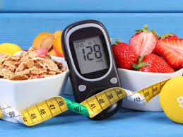
Digital Diabetes Remission
A national digital intensive weight management programme to support 3,000 people recently diagnosed with type 2 diabetes (T2DM). The national programme will run over three years and is expected to help around 40% of patients achieve remission from T2DM by the end of their first year on the programme.
The Scottish Government announced funding (£4.5m) for the programme in March 2025.
Delivery Milestones - Key Highlights
- Recruitment to clinical leadership and programme team roles is ongoing.
- Pre-tender Commodity Advisory Panel meetings completed and service specification being finalised ahead of the procurement of the national digital programme provider.
- Procurement tender for digital programme provider scheduled to be issued to market mid-July.
- Communications, and benefits realisation planning in progress.

