

Accelerated National
Innovation Adoption
(ANIA)

Post IDA Brief

November 2025

Background to ANIA 2
Innovations being assessed at Strategic Case 5
Innovations Being Assessed at Value Case 6
Innovations in delivery 7

Background to ANIA
The ANIA pathway, led by the Centre for Sustainable Delivery, in partnership with NHS National Services Scotland, Healthcare Improvement Scotland, Public Health Scotland, and NHS Education for Scotland, has been established to:
- identify innovations that should be considered for national adoption within the NHS
- produce robust value cases to assess their clinical and financial impact
- lead the national adoption of approved technologies at pace

The ANIA pathway is governed by the Innovation Design Authority (IDA), which brings together senior Scottish Government and NHS leadership. The IDA enables improved partnership working, system leadership and collective decision making relating to which technologies should progress through the ANIA stage gates.
Further details on these stage gates are provided on the next page and on the ANIA website.
Click here to view the ANIA website.
New market-ready technologies can also be referred to: Scotland Innovates
Decisions / key updates from 28 October 2025 IDA meeting
- Approval of the Chest X-ray AI Change Request to submit a Value Case in the next financial year due to availability of technical expertise.
Substantive items requiring decision at the 17 December IDA meeting
- Q3 Horizon Scanning Report.
- Intelligent Liver Testing Strategic Case submitted.
- Home-testing devices for diagnosing obstructive sleep apnoea hypopnoea syndrome (OSAHS) Strategic Case submitted.

Current technologies within the ANIA Pathway
The technologies that are currently being assessed for adoption via the ANIA Stage Gates, or are being deployed nationally following approval, are outlined over the following pages.

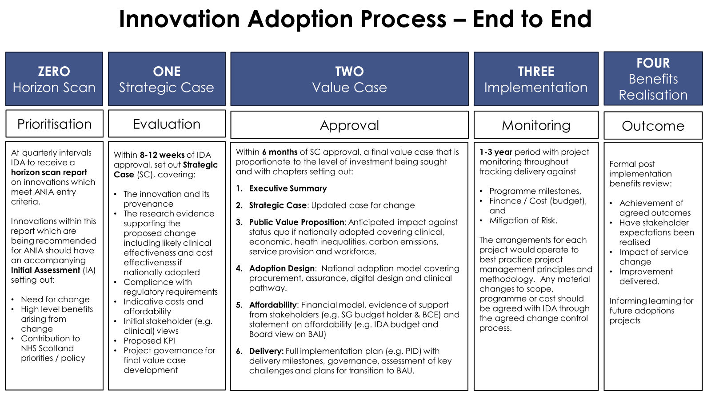

Innovations being assessed at Strategic Case
Strategic cases provide an early view of evidence, clinical acceptance, and cost effectiveness for technologies that have been identified through the Horizon Scan process and approved by the IDA. They are completed within 16 weeks.


Intelligent Liver Testing
This Strategic Case will explore how the introduction of two blood tests can reshape the chronic liver disease (CLD) pathway by delivering earlier and more accurate diagnosis. The combined use of the Intelligent Liver Function Test (iLFT) and the Enhanced Liver Fibrosis (ELF) test can help reduce pressure on clinical waiting lists by accelerating decisions about which patients with suspected liver disease require referral to specialist liver clinics and which can be safely managed by their GP.
The Strategic Case will be presented to the IDA in December 2025.
OSAHS Home Testing Devices
This Strategic Case will explore how home testing devices for diagnosing Obstructive Sleep Apnoea Hypopnoea Syndrome (OSAHS) have the potential to enhance sleep services across Scotland - improving quality of life and easing pressure on NHS resources. Poor sleep is associated with worsened mental health (including anxiety, stress, and depression), physical health issues (heart disease, high blood pressure, obesity, and type 2 diabetes), and reduced cognitive function, which can have serious safety implications.

The Strategic Case will be presented to the IDA in December 2025.

CT Fractional Flow Reserve

This Strategic Case will explore CT Fractional Flow Reserve technology that can help transform cardiovascular care. The technology converts a standard CT scan into a detailed 3D model of the coronary arteries, allowing clinicians to diagnose life-threating coronary heart disease in just 20 minutes. The alternative is that patients may have to go to hospital for an invasive and time-consuming angiogram. Using this technology means that people could be seen, diagnosed, and treated more quickly, resulting in better care for patients and reduced pressure on the service.

Work on this Strategic Case will start in January 2026.
Innovations Being Assessed at Value Case

Lung Cancer AI

This Value Case proposes:
Accelerating the diagnosis of lung cancer following a GP requested chest x-ray by the national deployment of a ‘24/72’ diagnostic pathway enhancement where X-rays identified by the AI technology as ‘high risk’ will be reported within 24 hours and diagnostic CTs will take place within the subsequent 72 hours.
This provides a unique opportunity to be the first UK nation to implement a national AI-enabled Lung Cancer diagnostic pathway enhancement.
The Value Case is expected to be completed during financial year 2026/27, when the necessary technical expertise will be available to complete the digital design and implementation plan.

Innovations in delivery
Technologies which have been approved for national implementation by both Scottish Government and NHS Scotland Health Boards.

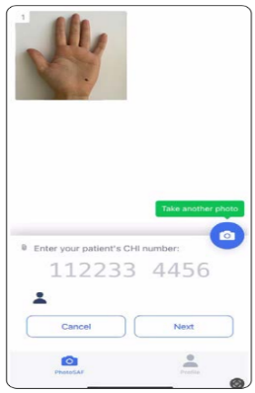
Digital Dermatology
This is the national deployment of an image capture pass through app which enables Primary Care clinicians to use their own phone cameras to easily, and safely, take images of a patient’s skin condition at the point of referral to Dermatology. The use of triage-quality images as standard practice will provide all Dermatologists with the ability to carry out robust referral triage which can significantly speed up diagnosis and improve waiting times, enhancing patient journeys and outcomes.
Delivery milestones - Key highlights
- All GP practices across Scotland have access to securely take and send skin images safely when referring patients to dermatology.
- The ANIA Programme ended on 30 September 2025. The Modernising Patient Pathways Programme (MPPP) within CfSD will continue to support Boards with embedding the pathway
- Work is underway to improve the user experience in relation to re-authentication. Two connected solutions have been identified 1) an update to the app to enable biometric sign in at the point of launching the app and 2) extending the NHS Security token from 24 hours to 30 days. NHS Lothian has been identified as the proposed Health Board to undertake a pilot of the proposed upgrade, initially with a small number of GP practices before wider roll out.
Pharmacogenetics

This delivery programme includes two genetic tests:
- A lab-based test (CYP2C19 Genotype Testing) to identify ischemic stroke and transient ischemic attack (TIA) patients who are resistant to Clopidogrel.
- A Point of Care Test (POCT) for neonates to prevent permanent hearing loss caused by gentamicin-induced ototoxicity.
Following approval by the Innovation Design Authority and the NHS Executive Leadership Group, the Scottish Government announced funding (£1.9m) for the programme in March 2025.
Delivery milestones – Key highlights
- NHS Western Isles and NHS Grampian (Dr Gray’s) went live with the lab-based CYP2C19 Genotype Testing Pathway on 27 October initially for verification tests.
- 12-month CYP2C19 POCT Test of Change went live in NHS Grampian on 27 October and in NHS Western Isles on 3 November.
- NHS Greater Glasgow and Clyde went live with the Neonatal Gentamicin POCTpathway in the Royal Hospital for Children (SCBU) on 20 October.
- Recruitment within the two Genetic Labs continues with 4 out of 9 posts appointed
- Anticipated order of adoption developed for both projects based on Health Board feedback.
- Launch event for CYP2C19 Genotype Testing took place on November 13 in NHS Tayside.
- Launch event for Neonatal Gentamicin POCT took place on November 21 in NHS Greater Glasgow and Clyde.
- Benefits realisation strategy drafted for each project.

Click the link for further information regarding the recent Scottish Government Ministerial visit: https://www.nhsggc.scot/genetic-test-to-prevent-hearing-loss-in-newborns-to-begin-national-rollout-in-nhs-greater-glasgow-and-clyde/

Digital Diabetes Remission
A national digital intensive weight management programme to support 3,000 people recently diagnosed with type 2 diabetes (T2DM). The national programme will run over 3 years and is expected to help around 40% of patients achieve remission from T2DM by the end of their first year on the programme.
The Scottish Government announced funding (£4.5m) for the programme in March 2025.
Delivery milestones - Key highlights
- Recruitment to Implementation Team roles, including Clinical Leads, is complete.
- National supplier framework award is now complete with Counterweight being the successful provider. Pre-implementation activity with the supplier is underway.
- A communications toolkit is in development. Focused engagement with Health Boards and Primary Care has begun, with further engagement planned to include eHealth and Information Governance Leads.
- The development of the National SCI-Gateway protocol is in progress.
- National Information Governance documentation in development.
- Benefits realisation strategy has been approved by the Programme Delivery Board.


Ambulatory ECG Patch Monitors
A national remote diagnostic pathway for the adoption of adhesive single lead ECG devices (patches) for post cryptogenic stroke and transient ischemic attack (TIA) patients that provide continuous monitoring for up to 14 days. The introduction of this pathway is predicted to prevent 689 recurrent strokes and deliver £14.6 million resource savings for NHS Scotland over five years.
The Scottish Government announced £1.9 million in funding for the programme in September 2025.
Delivery milestones - Key highlights
- Programme funding announced on 24 September 2025 by the Health Secretary during a visit to NHS Greater Glasgow and Clyde.
- Programme Delivery Board meetings are scheduled with Board Chief Executives asked to nominate their Board Senior Responsible Officer to join the Programme Delivery Board.
- Recruitment has started for the Implementation Team – Project Management Team and Clinical Leads.
- Procurement Specification continues to be developed.

Click the link for further information regarding the recent Scottish Government Ministerial visit: Innovation to transform lives of stroke patients - gov.scot
Digital Type 2 Diabetes Prevention
National deployment of the Digital Type 2 Diabetes Prevention Programme for 15,000 people living with pre-diabetes in Scotland over 3 years, which is predicted to prevent almost 4,000 people progressing to type 2 diabetes over 5 years post intervention, delivering almost £20 million of net savings for NHS Scotland.
The Scottish Government has now committed £4.8 million to support this initiative.
Delivery milestones - Key highlights
- Programme funding was announced on 1 November 2025, after a visit by the Minister for Public and Women’s Health during a visit to NHS Lothian.
- Programme Delivery Board meetings are scheduled with Board Chief Executives asked to nominate their Board Senior Responsible Officer to join the Programme Delivery Board.
- Recruitment has started for the Implementation Team – Project Implementation Team and Clinical Leads.
- Procurement Specification continues to be developed.
Click the link for further information regarding the recent Scottish Government Ministerial visit can be found here: Improving health through prevention - gov.scot.

